Explains LLM strengths and failure modes

As per my understanding, LLMs are strong because drafting, rewriting, summarizing and changing tune, this is the core skill of LLM. They can pull material from the long documents, messy nodes and it could transform them into a clear structure.
They can refactor debug patterns in popular languages and frameworks. So they can transform the content into tables, JSONs or the data into tables, JSONs or checklists and they can check it. It can check it again whether it is correct or not. It could also provide a step by step reasoning which could be if you are working on a problem which require multiple steps of reasoning LLM provide that and
why they fail is because of the hallucination, it could produce a confident text, which is wrong or made up citations.
It could have stale knowledge and could provide data which is very old. If there are small changes in the wording, it could change the entire answer & the context. So you could get generic results or weak responses. It agrees very easily. And sometimes it does not match the accuracy but it is very confident in the answers.

Understands context engineering

Context engineering usually means deciding what goes in the models context. It covers what model sees, instructions, documents and results, memory and the conversation history.
When I mean it goes in the context, it means it takes system instructions, task, what the user actually wants right now, the rag, which are the relevant document chunks, search results, or the database that has been pulled during the runtime. Tools, what the model can call to get the results in like during the to return the results history like what summarizing was there earlier and demonstration of the output that we that the user wants.
There are certain code techniques in this which is it retrieve what's relevant. It structures the data in clear sections.

When I mean it goes in the context, it means it takes system instructions, task, what the user actually wants right now, the rag, which are the relevant document chunks, search results, or the database that has been pulled during the runtime. Tools, what the model can call to get the results in like during the to return the results history like what summarizing was there earlier and demonstration of the output that we that the user wants.
There are certain code techniques in this which is it retrieve what's relevant. It structures the data in clear sections.It keeps the key instructions near the start or the end so that long documents usually work. It contains old prompts and tools output so the window does not fill with noise.

It keeps the data at runtime fresh rather than relying on training knowledge. fences or treat the untrusted content as data so that it does not hijack the agent the data inside it does not hijack the agent.

RAG

RAG, which usually is known as Retrieval Augmented Generation. It means fetching relevant information from the data that we have stored at the time the user ask a question and putting it into the model's context. And the model will answer it from the RAG material that we've stored. we use it for the knowledge and model lags because it retrieves the data from our own data. It retrieves the answer from our own data. So the hallucinations are very less.

We could actually see that from which document it has cited this answer. And whenever we update the data, the answers also update.

What we do as a pipeline is first is basically indexing the data. First we load the documents, web pages or whatever data that we have, we chunk them into pieces and then we embed each chunk which turns into a vector and whenever user asks for a question the vectors which are nearest to the questions usually 5 to 20 or 25 the answer is given from that right at the time of retrieval the users question is embedded in the model in which rag is there and the data is being filtered via metadata wherever it helps.

The LLM usually answers from the chunks and it cites from its source. As the owner of the agent or the platform, we need to tell our model to say, I don't know, when the data and the chunks are not available. What makes RAG work well is its hybrid search, re-ranking of the vectors to better provide the results, good chunking, query rewriting and storing the date sources and permission with the chunk which in turns into a metadata.

Understands tool use and MCP

Tool use is like functional calling. So on its own, LLM can only produce text and give as a result. Tool use lets it ask the application to do something, maybe a search query, maybe an API or to run a code search basically query a database and how it works we define the tool when we are giving a prompt. So we give a name description and in the JSON schema or the input schema that is there. When a model decides whether it needs to use a tool or not, then the code runs the tool.

It sends the result back to the model as a tool result and the model continues and repeating the loop makes it an agent. And what makes this tool work well is clear descriptions. Schemas are very solid or tight. The results are very concise. And it asks for human approval and typically works as a guardrail. Coming to MCP, which is a model context protocol. It was developed by Anthropic. It's basically USB-C for AI, so if there is any MCP supported application, we can simply connect it.

And why it was introduced? Because every AI app used to wire with its own integration. So it would be N apps and X apps and Y tools, then it's going to be X into Y custom integrations connections which is very huge work so MCP was introduced.

Distinguishes workflows from agents

Both workflows and agents, they both use LLMs and tools. The onlydifference is who decides what is the next step. In case of workflow,the code decides and in case of agent, the model decides.

And the differences between workflow and agent is first on the control of the flow. In workflow it's written in the code but in agent it's decided by the model. Workflows predictability are high since it's a designated path. For agent it's lower because the path varies. Workflow is best for well defined and repeatable tasks. Agent is best for open ended tasks where steps are not known. Workflow cost is low and agent's cost is higher.
Debugging a workflow is easy and for agents it's harder.

Draws the architecture of an AI feature, Asks informed architecture questions

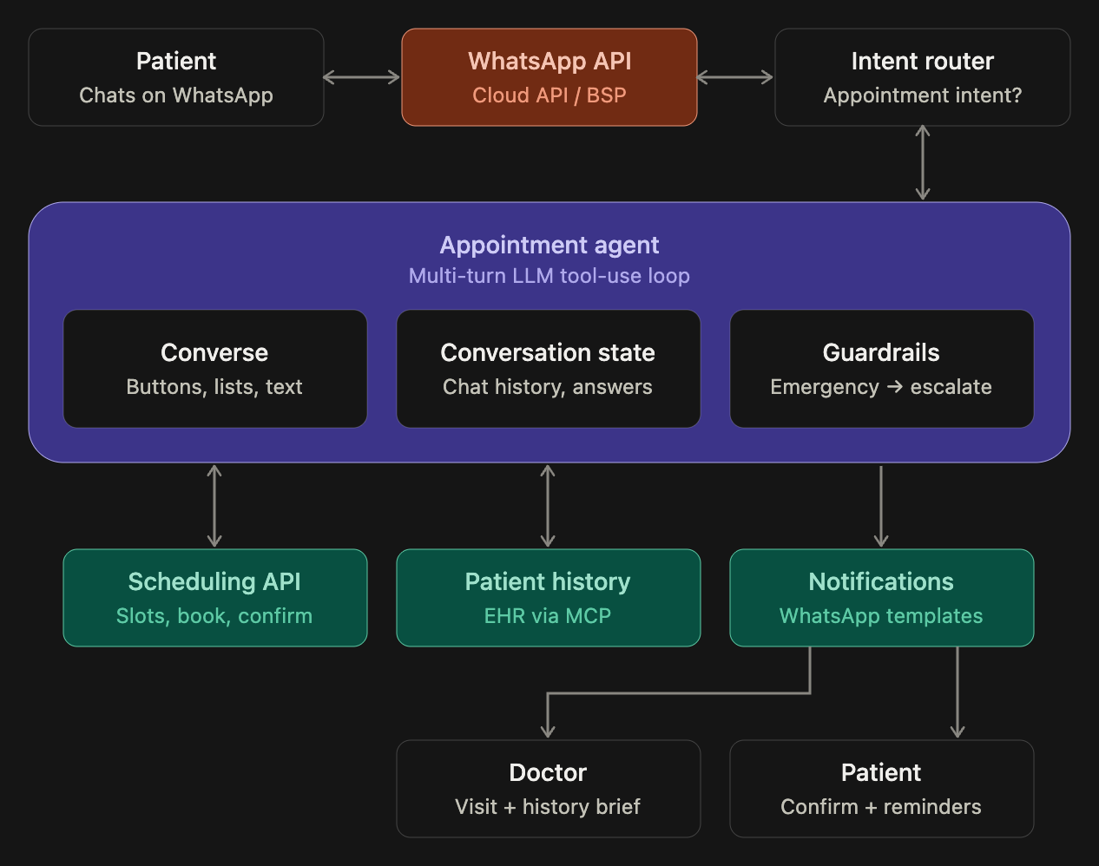

Channel setup
- Use the WhatsApp Business Platform, either Meta’s Cloud API directly or a provider like Twilio, Gupshup or Interakt. Incoming messages reach your backend through a webhook, and the agent replies through the same API.
- You need a verified business account, a dedicated phone number and the patient’s opt-in.
Richer conversation
- Reply buttons (up to 3) for quick choices like Book / Reschedule / Cancel or Morning / Afternoon.
- List messages (up to 10 rows) for picking a doctor or one of the available slots. Taps cut down on typos and parsing errors compared with free text.
- Media: Patients can send voice notes (transcribe them before passing to the LLM), photos of prescriptions, or lab report PDFs. The agent can attach these to the doctor’s brief.
- Location pin for the clinic address in the confirmation.
The 24-hour window (the biggest design constraint)
- After the patient messages you, you can reply freely for 24 hours. These replies are generally free.
- Outside that window, you can send only pre-approved template messages. Plan for reminders (“Your appointment is tomorrow at 10:30”), follow-ups and re-engagement templates. Submit them to Meta for approval early.
- The doctor notification should usually go through your internal app, email or a doctor-facing template, not a free-form WhatsApp message.
Conversation state
- Store the chat history and collected answers per phone number, with a timeout. Patients may reply hours later, so the agent should pick up where it left off (“Still want the Thursday 4 PM slot?”).
Policy and privacy
- Meta’s policy allows bots built for specific business tasks like booking and support, but not general-purpose AI assistants. Keep the agent scoped to appointments and hand anything else to staff.
- WhatsApp is end-to-end encrypted in transit, but your backend and LLM provider still handle the data. The earlier rules still apply: verify identity, don’t send detailed medical history in the chat, and keep audit logs and data processing agreements in place.
- Check Meta’s business messaging policy for healthcare-specific restrictions before launch.

